The Grief Protocol

Solutions to Address Our Bodies’ Hardwired Reaction to Grief
by Karen E. Weitz LMT
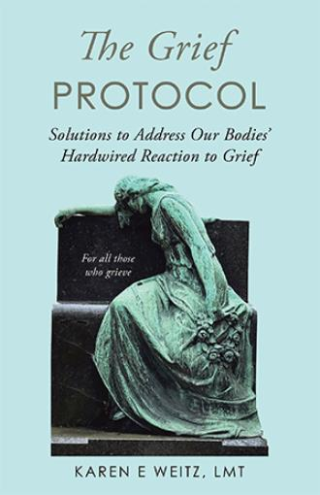
About the Book
Grief triggers a “freeze/collapse” response in our nervous system hardwired to protect us. Yet, unprocessed grief causes a glitch in the flow of our bodies’ electromagnetic energy field. According to Traditional Chinese Medicine (TCM) this glitch is referred to as “dis-ease” which is believed to be the pathological origin of diseases.
The goal of The Grief Protocol is to override this hardwired reaction to reset your nervous system and restore the proper flow of your electromagnetic energy.
It teaches how to clear any blockages in our electromagnetic energy flow, process the energy of emotions, and expand our neuro pathways while strengthening our mindfulness, all of which fortifies our resilience to stressors. Ultimately, processing grief as it arises enables us to alchemize this intense emotion back to its pure form: love.

About the Author
Karen’s grief journey began in 1999 when both of her parents were diagnosed with their respective cancers within four months of one another.
She found it difficult to physically process the intensity of her grief despite operating her practice as a licensed massage therapist, receiving regular body work, and meeting with a trained grief counselor.
Years passed, along with more deaths, grief, and heartaches. Karen thought the growing intensity of her physical reaction from these losses were normal and were expected if one lived a life connected with others.
That all changed in 2023 when she intuitively applied somatic techniques to address her body’s physical reaction to grief. Since that time, she has found tremendous healing guiding others through the pain she has had the courage to process.
Karen resides in Portland, Oregon where she attended East West College of the Healing Arts. She has a tricolor corgi named Winifred who wants to be loved on by all good humans.
https://www.balboapress.com/en/bookstore/bookdetails/866438-the-grief-protocol

